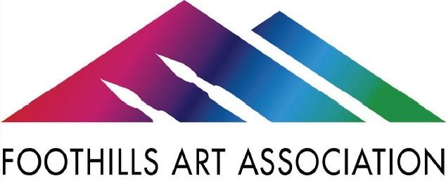
January 6, 2025 Board Meeting Minutes
Attendance
Barbara Drews | Bonnie Owen | Michele Barbour
Judi Zander | Roz Oserin
Lloyd Smith | John Engen | Guest: Parva Zarei

1) Call meeting to order by Roz at 10:00 a.m.
2) Roz welcomed our guest, Parva Zarei, who has expressed interest in becoming a vice-president.
Parva introduced herself and gave a bit of her history of work and art. Roz provided some background for the president/vice-president positions and what the association needs from the person(s) in that role.
3) Motion to approve the minutes from the December 2024 meeting was made by Lloyd, seconded by Barbara, and approved by all.
4) Standing Committee Reports – Report of new volunteers
a) Featured Artist – Grossmont Union High School District: reception January 13th, 5;30-7:00
b) Membership -One new member
c) Exhibition Committee – Hanging is complete with 74 paintings.
d) Demo/Workshop – February’s demo artist is Lucas Smith. His workshop will be Sunday, February 9th, 10:30 am – 1:30 pm.
e) Treasurer – Roz distributed copies of the current 2024-2025 financials showing July through December income and expenses. She highlighted key figures, such as the results for Wildlife in Art and discussed certain findings, such as more membership payments are being paid online. She also highlighted some donations, particularly The La Mesa Village Association who donated $2,000 to our new Hanging System.
f) Website/Online Gallery – John continues to work on the digital virtual gallery, but keeps the traditional online gallery foremost.
g) Gallery Coordinator – Michele Barbour reported that Saturdays continue to be the hardest to fill for Gallery Sitters. Holidays are typically more difficult to schedule.
h) Gallery Supplies – Lloyd reported that all is going well. There is a new cleaning lady who will clean the gallery once a month.
i) Social Media – John is currently filling in and took photographs of the high school work and will post them.
j) Classes – Stephanie Henry has volunteered to be coordinator. She will attend next month’s board meeting to give an update.
5) Old Business
a) People’s Choice Awards – Roz sent message to JoAnn Bray and Barbara Drews asking for their help to choose someone from either the take-in and the hanging committee to manage this monthly award. Someone on their team needs to count votes in plexiglass box, get the People's Choice Award folder from the file cabinet, tape gift card to back of painting, call the winner, ask if we can keep the painting for the next month to display, take a photo of the painting, and send it to Judi Zander so she can add it to the newsletter.
b) Farmer’s Market & Foothills Fridays for 2025
Glenn Osga has volunteered to manage the Farmers Market portion. Bonnie Owen has volunteered to manage the gallery reception volunteers for these events (4:00-6:00 pm on the second Fridays April-September).
c) Taking payments for art sales
In addition to other gallery sales, there have been two sales from the Bin Art since we began offering this in November.
Discussion of how artists provide their QR codes (Venmo/Square/Paypal etc.). Gallery takes cash, checks made out to artist (if artist approves via phone call), or QR codes. Roz started a page in our Monthly Shows folder which has her Venmo card. All artists may add theirs to this folder if they like. This will help expedite sales. The artist will still need to be contacted, but the transaction can be done over the phone with the artist through these different payment apps. We will revisit this next month to note progress and add details for our gallery sitters on how to do this.
6) New Business
a) New member orientation – The New Member email includes detailed information. However, many members need face-to-face. Roz suggested using the 30-minute social time for orientation, before the meeting begins. Roz will do this for the 5:00 o’clock meetings. Need person available during the day for December – February meetings that begin at 2:00 pm. Parva has volunteered for February’s meeting. Discussion of recording/filming members meeting and artist presentations.
b) Budgeting for new hanging system
Roz shared some ASHanging.com hanging systems. Discussion of how it works. Lloyd, John, and Bonnie volunteered to measure & count how many cables, hooks, etc. needed to determine cost and where we can save money. Reminder that we will need approval from City of La Mesa, who owns the building.
c) Parva has volunteered to be Vice President.
7) Meeting adjourned at 11:35 a.m.

